**WONDERFUL JOURNEY DOCUMENTATION**

This web application is the final exam project for my Web Programming course. The website is Wonderful Journey, a blog website that features tourism destinations in Indonesia. Users are allowed to write their travelling experience when enjoying their travel in Indonesia.

**Home Page**

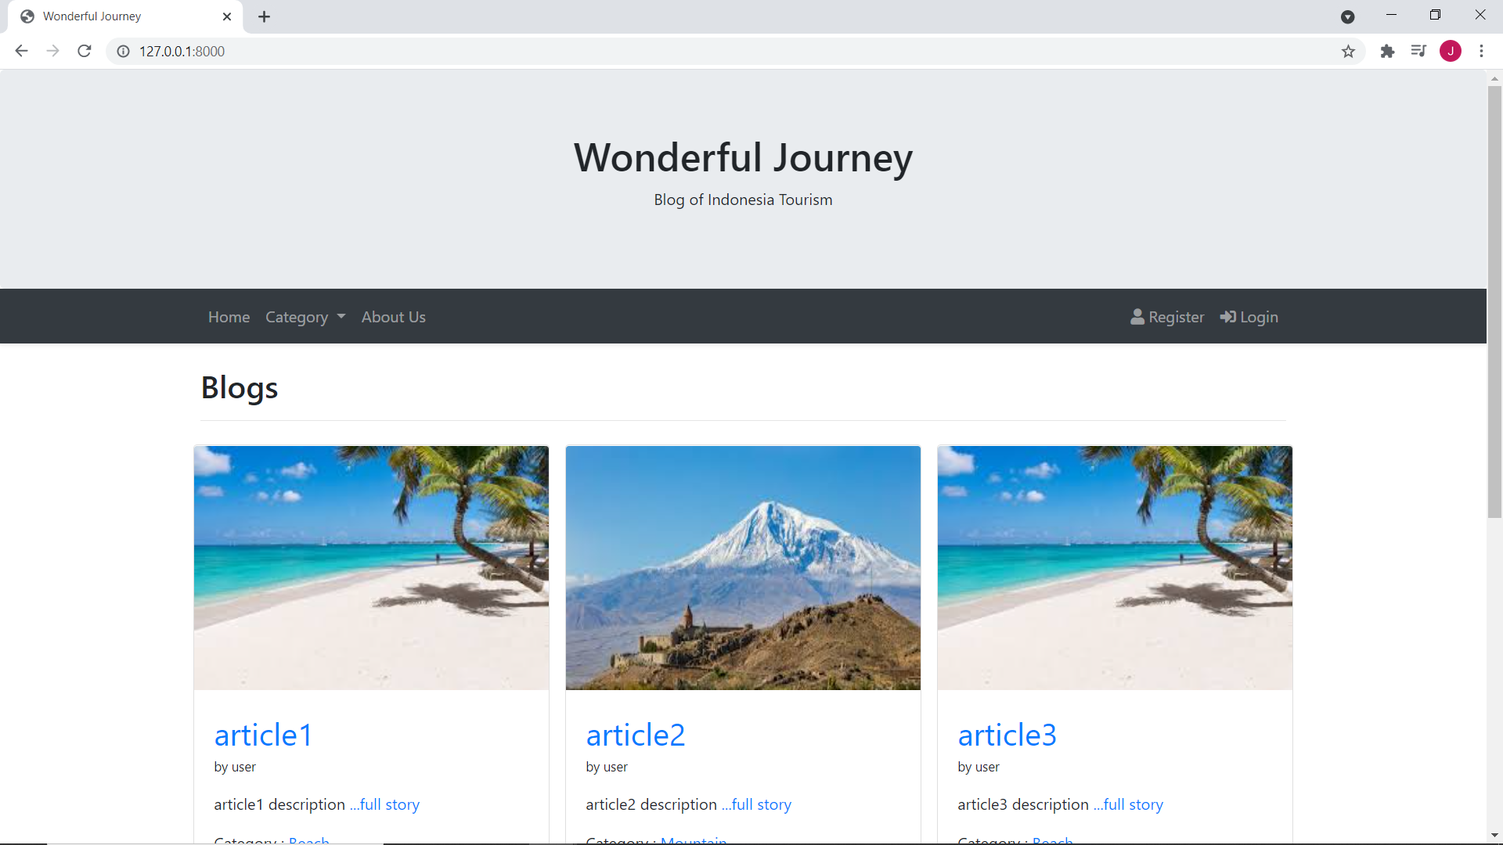

**Blogs based on their category**

The blog article can be viewed by their corresponding category.

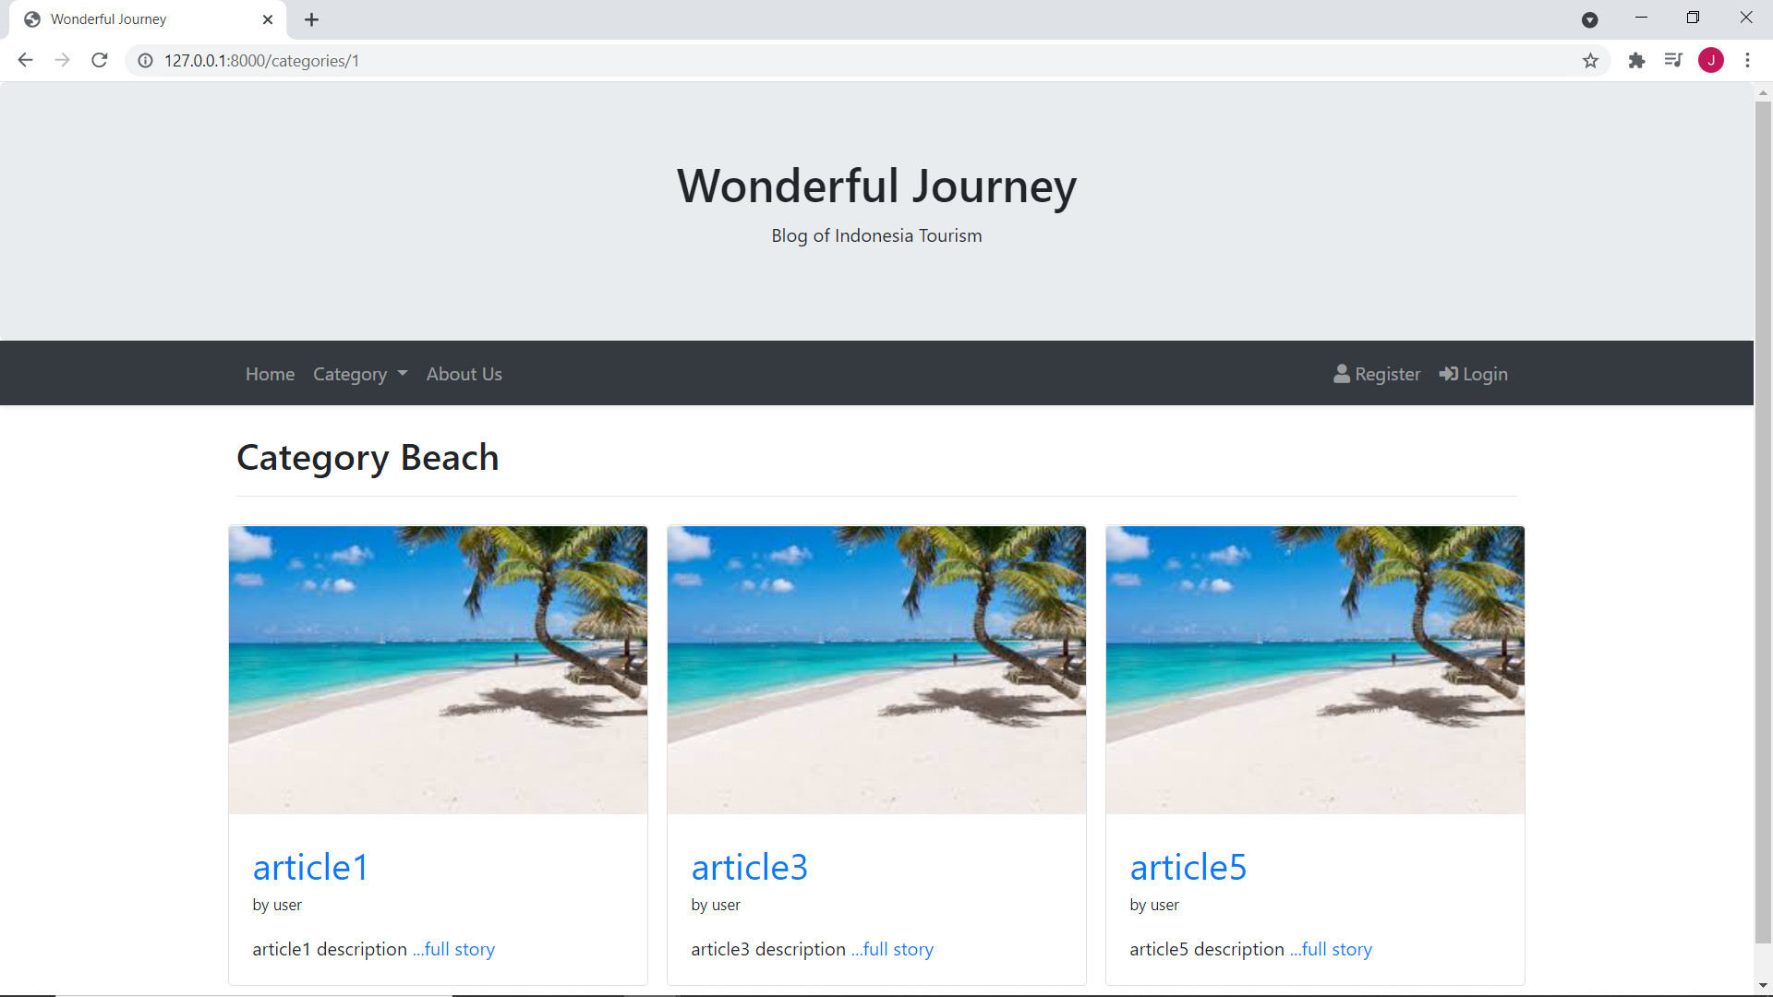

**Full Story**

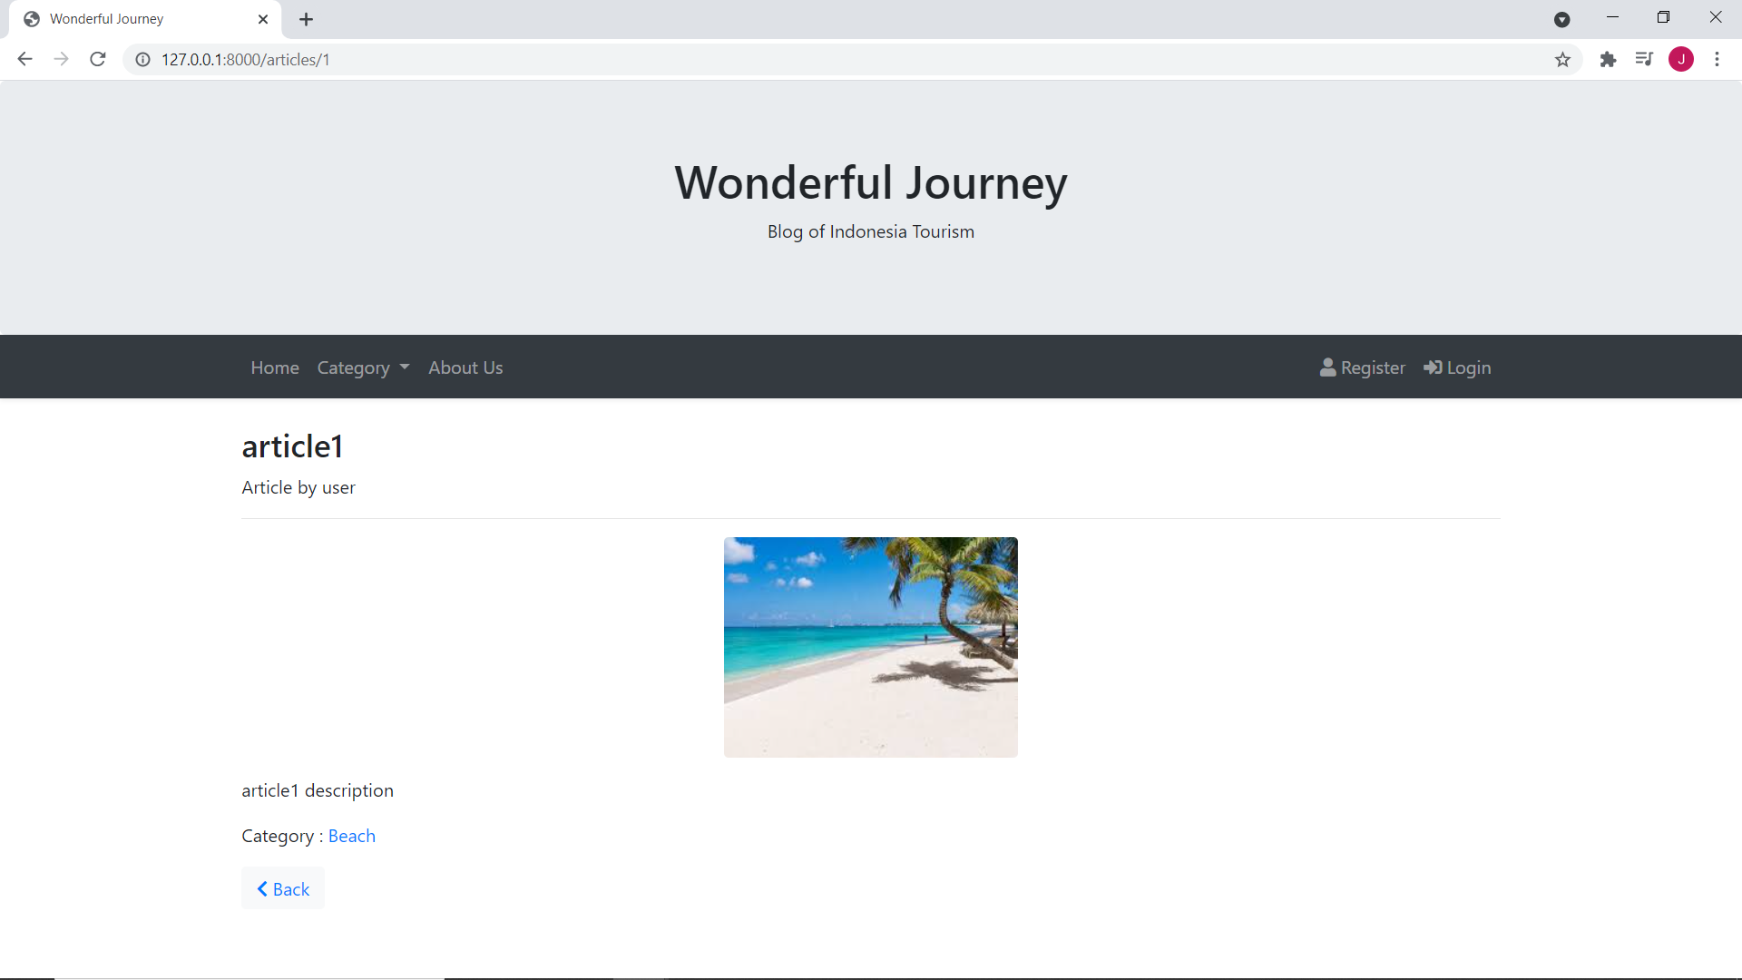

There are 2 user types in the web application, **Admin** and **User**. Admin user will control and administrate the website. The admin can delete user article or delete user account if the user does not follow the web guidelines. The admin data is added manually via the database seeder.

**Login Page**

We can choose to login as admin or as user using the dropdown menu. There is also a remember me feature which will store the cookie session and persist the user credentials.

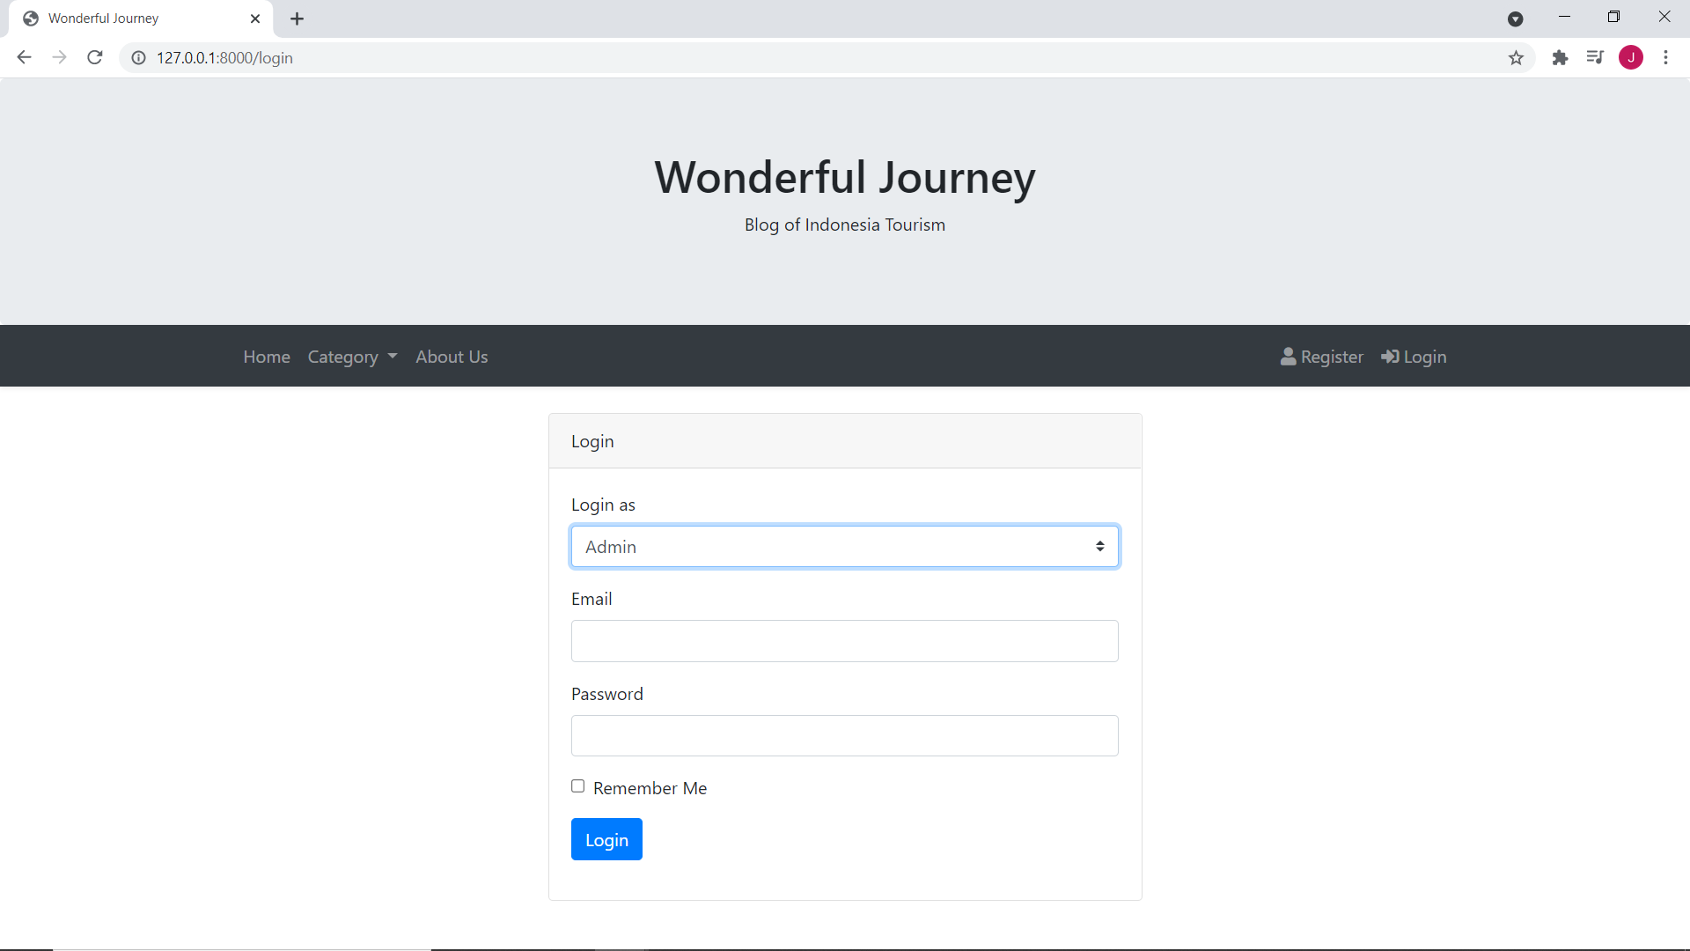

**Admin Landing Page**

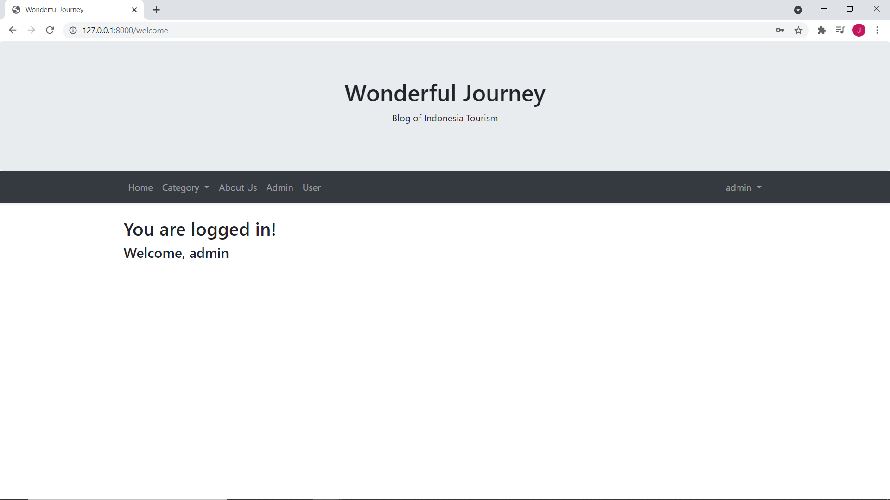

**Admin: manage blogs**

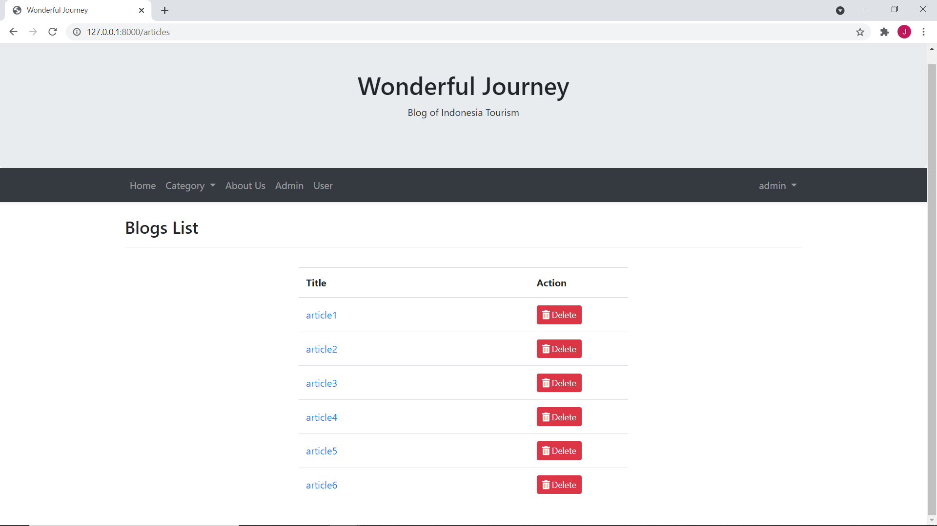

**Admin: Manage users**

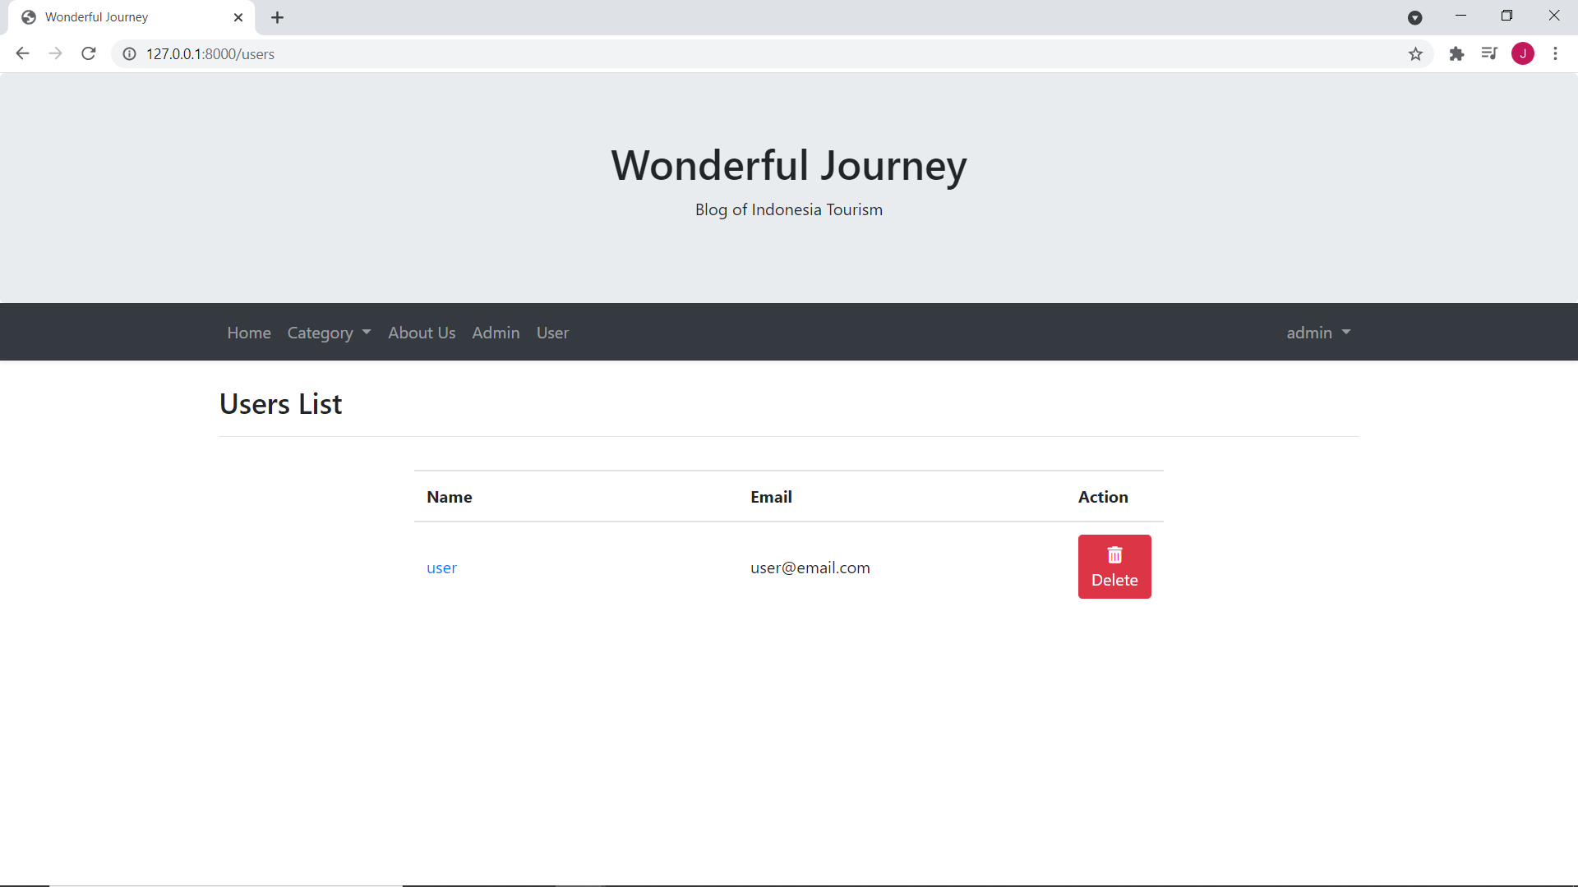

**User: update profile**

Users can update their profile which includes their name (viewed as the author of article), email (used for login), and their phone number.

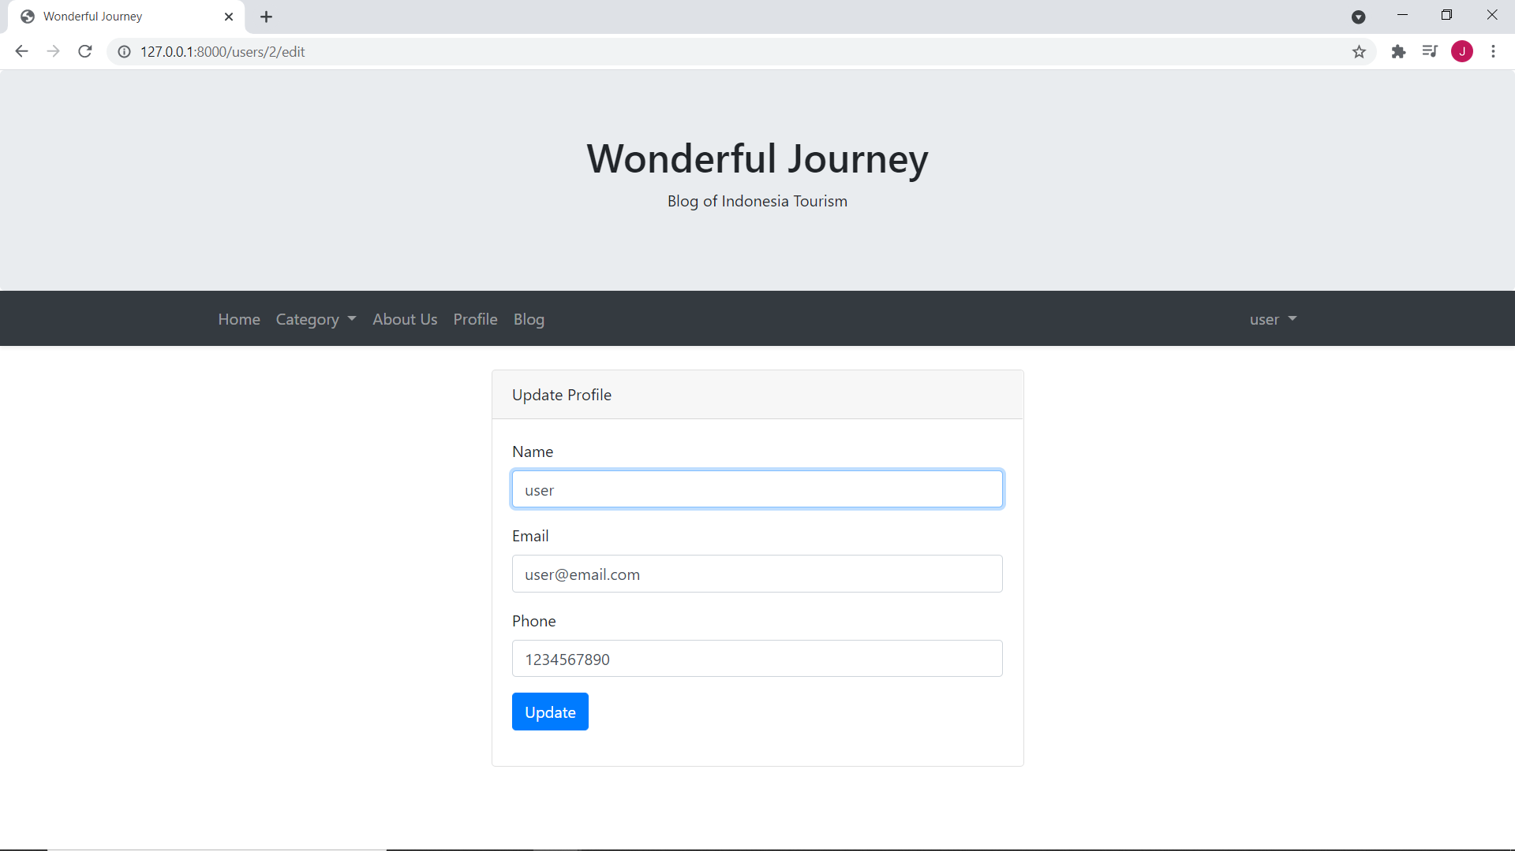

**User: manage blogs**

From this page the user can create and delete their created blogs.

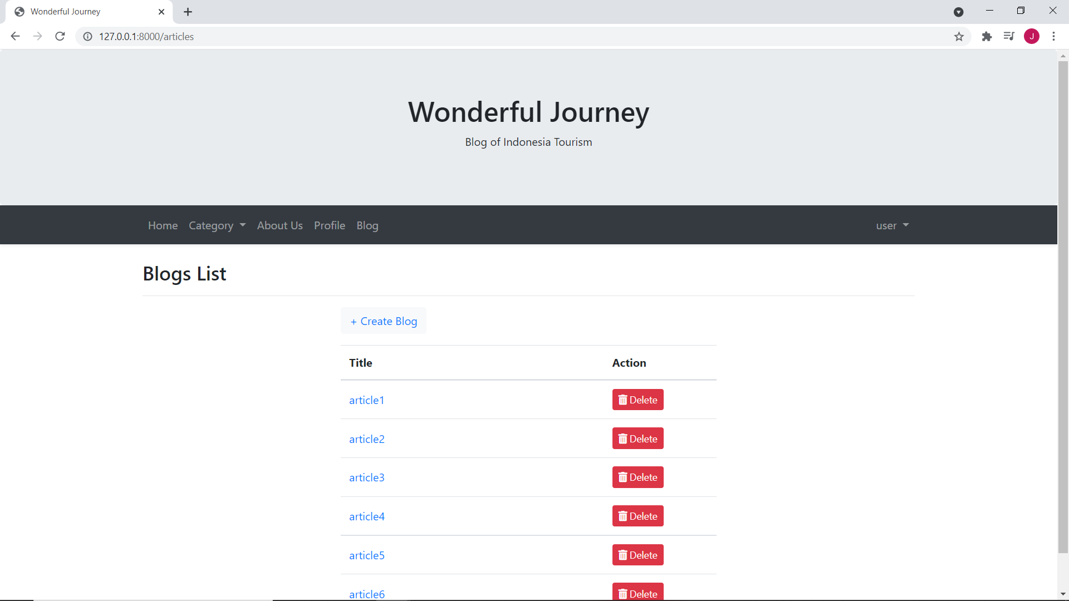

**User: create new blog**

